Dynamic Malware Detection using Network Traffic Analysis

Tech_Doc_!S3

Aishwarya Thirumalai
Osarumwense Orumwense

Pragnya Manaswini

ITMS548
24 November, 2014

ABSTRACT

Dynamic Malware Detection using Network Traffic Analysis

Bots are one of the most sophisticated and popular types of cybercrime today. They allow hackers to take control of many computers at a time, and turn them into "zombie" computers, which operate as part of a powerful "botnet" to spread viruses, generate spam, and commit other types of online crime and fraud. In our project, we will provide a proof-of-concept botnet detection mechanism using a clustering analysis of network flows and we will work on a mechanism that is not dependent on specific botnet signatures or architectures.
First, a simple network is created with some simple network services running, this is to simulate a real network with lots of network activities. Then network activities are monitored and network traces are collected. This serves as a clean trace of network that has not been infected. Next, to simulate an infected network, we will use Metasploit, a tool used by penetration testers to find network vulnerabilities that can be exploited. Also, network activities are monitored and traces saved, to simulate an infected network. After this, both traces are analyzed to determine if an infection exists.

TABLE OF CONTENTS

ABSTRACT II
TABLE OF CONTENTS III
INTRODUCTION 1
EVOLUTION OF BOTNETS 2
BOTNET ARCHITECTURES 4
TOOLS/SOFTWARE USED 7
NETWORK ENVIRONMENT 8
INSTALLATION OF TOOLS/SOFTWARE 9
PROJECT IMPLEMENTATION 10
REFERENCES 11

Introduction

Bots are one of the most sophisticated and popular types of cybercrime today. A BOTNET is a network of compromised bots (“bots”) connected to the Internet that is controlled by a remote attacker (“botmaster”). Once botnet infects a computer, a bot steals personal information , credentials and performs designated malicious attacks.
Botnets are effective in performing tasks that would be impossible given only a single computer, single IP address, or a single Internet connection. Originally, botnets were used for performing distributed denial of service attacks. However, most modern webservers have developed strategies to combat such DDoS attacks, making this use of a botnet ineffective. Additionally, many counter-DDoS strategies blacklist the IP addresses of attacking computers, thus exposing the botnet's machines.
The level of diffusion of the botnets depends on the capabilities of managers to involve the largest number of machines trying to hide the activities of the malicious architecture. A critical phase in the arrangement of a botnet is represented by its constitution; the attackers have essentially two options, recruit bots diffusing a malware, typically via phishing campaign or sending the malicious agent via email.

Evolution of botnets

IRC bots:
Earlier bots were not so malicious as they are since the botnet explosion circa in 2004.
Before this, most bots used IRC as their control protocol. Initially, about 10-12 years ago,
IRC was used to connect chat rooms, which allowed people to echange messages. Now, we
have the instant-messaging protocols; ICQ, AIM, and MSN Messenger, IRC has lost its
popularity.The first bots was created to log into these chat rooms (called channels), ensuring
that the channel remained open and recognized the channel operators giving them control
over the channel.

Localized bots:
‘Bots’ ran exclusively only on windows. Now, the local version have also come up. Hackers
use scripting language like Perl and have created versions which were running on Linux and
Unix. This was created by a group of script-kiddies from Brazil, ‘Atrix-Team’.

P2P bots:
The IRC botnets are stil common, but they fail at the IRC server. If the server is shut down,
the hacker looses control of the bot army.
Eg. In 2007 a new kind of botnet arrived using the P2P protocol. This is the same protocol that many programs use to download music, for example. One of these botnets used an encrypted implementation that was based on the eDonkey protocol. This malware gained considerable notoriety: It was originally called W32/Nuwar but later gained fame as the Storm worm.

HTTP bots:
HTTP bots are very recent introductionfrom iRC channels. Evolution into HTTP began along with advances in ‘exploit kits’. They were developed by russian cybercriminals which also included Mpack, ICEPack and Fiesta. It can be installed on remote machinesand can be controlled by remote website as well.
Here the criminal sends a sppam or an instant message with variety of links to the potential victims. These are the links to website which already contains the exploit kit. The attack occurs dynamically, without the victim’s knowledge. If the exploit occurs successfully, it can then at a later point of time install a cocktail of the malware to gain remote control of already infected machines.

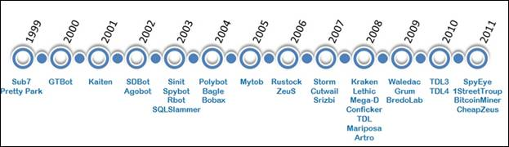

Botnet Evolution
http://www.scmagazine.com/botnets-the-backdoor-to-the-enterprise-network/article/242016/

Botnet Architectures

Centralized C&C architecture:
Most botnets that have appeared until now have had a common centralized architecture. That is, bots in the botnet connect directly to some special hosts (called "command-and-control" servers, or "C&C" servers). These C&C servers receive commands from their botmaster and forward them to the other bots in the network. From now on we will call a botnet with such a control communication architecture a "C&C botnet".
As botnet-based attacks become popular and dangerous, security researchers have studied how to detect, monitor, and defend against them. Most of the current research has focused upon the C&C botnets that have appeared in the past, especially Internet Relay Chat (IRC) based botnets. It is necessary to conduct such research in order to deal with the threat we are facing today. However, it is equally important to conduct research on advanced botnet designs that could be developed by attackers in the near future. Otherwise, we will remain susceptible to the next generation of internet malware attacks.
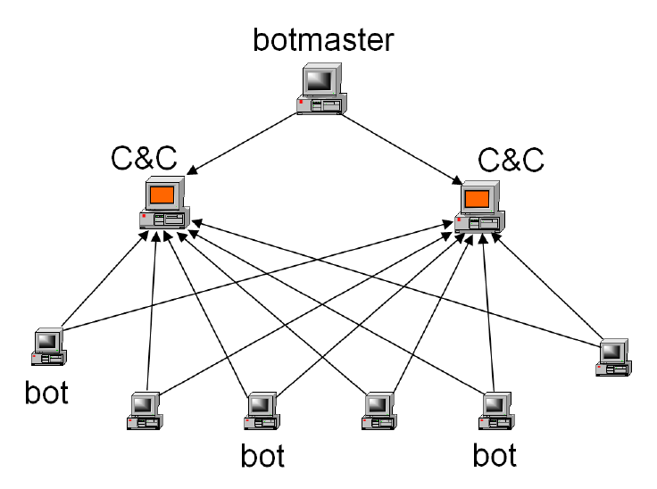
Centralized Botnet Architecture
https://www.usenix.org/legacy/event/hotbots07/tech/full_papers/wang/wang_html/

Peer to peer P2P botnet architecture:
A P2P network is a computer network in which two or more computers are connected and share resources (content, storage, CPU cycles) by direct exchange, rather than going to a server or authority which manages centralized resources. Today one of the major uses of P2P networks is file sharing, and there are various P2P. P2P networks can be distinguished in terms of their centralization and structure.

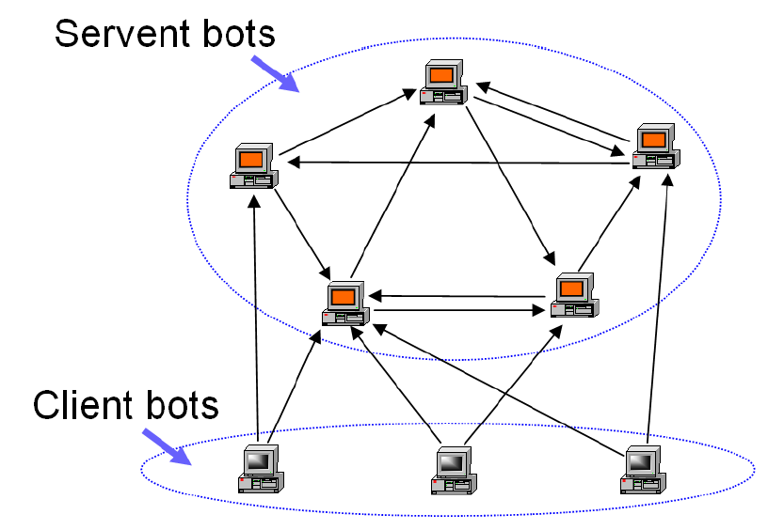
Peer to peer architecture

https://www.usenix.org/legacy/event/hotbots07/tech/full_papers/wang/wang_html/

Centralized Architectures:
In this class of P2P networks, there is a central server which maintains directories of metadata and routing information, processes file search requests, and coordinates downloads among peers. Napster was the first widely used P2P file sharing application, and used this centralized architecture.
Decentralized Architectures
In this there is no central server. All requests are handled by peers within the network. In purely decentralized architectures, each peer behavior is exactly the same. The peers act as a server when processing a file search query, and as a client when requesting a file. However, in partially decentralized architectures, peers with better computing ability and network bandwidth have the chance to be promoted and become “superpeers,” playing a more important role in the network.

TOOLS/SOFTWARE USED
VMWare Player- It is a development environment that allows system administrators to create and run virtual machines (VMs) directly on a computer system for various purposes like patch testing, software compatibility tests and a host of others.
Windows XP
Kali Linux- It is an advanced Penetration Testing and Security Auditing Linus distribution. It is mainly used by penetration testers and network security specialists primarily to determine how vulnerable a network is.
Apache Web server- it is generally recognized as the world’s most popular web (HTTP) server.
File Transfer Protocol (FTP) - It is used to transfer files between computers on a network.
Wireshark- it is a network packet analyzer. It captures network packets and displays those packets data as detailed as possible.
Snort- Snort is free and open source IDS (Intrusion detection system) and in some cases, IPS (Intrusion Prevention System).
Metasploit Framework- It is a tool for developing and executing exploit codes against a remote target machine.

NETWORK ENVIRONMENT
For the purpose of this project, we will be configuring a small and simple virtual network using VMWare. The network will consist of three systems.
System 1
This will have Windows XP installed. This will serve as the target system, since Metasploit targets a particular system or systems on a network. Also installed will be Apache HTTP web server and FTP server so this system will serve as both a web server and a FTP server.
System 2
This will also have Windows XP installed but it will act as a HTTP client and a FTP client. As this system is requesting for both HTTP and FTP services from system 1, HTTP and FTP traffic are generated which will be captured and saved by Wireshark.
System 3
This will have Kali Linux installed. This will serve as the attacker system. Kali Linux already has Metasploit Pre-installed, so it is from this system we will launch our attack on the target system (system 1).
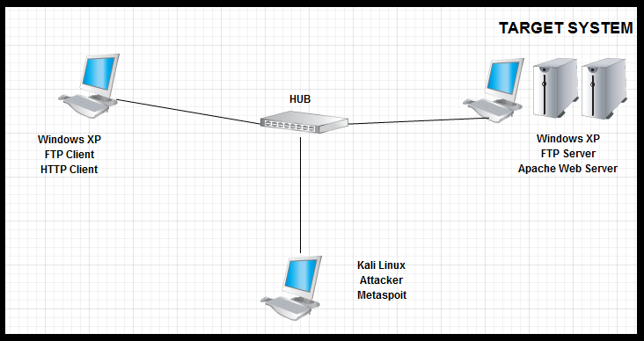
Simple Diagrammatic representation of the network

INSTALLATION OF TOOLS/SOFTWARE

For this project, we will be installing the following;
- VMWare Player
- Windows XP
- Kali Linux
- Apache Web Server
- FTP server
- Wireshark
- Snort
- Metasploit

For the individual installation and configurations of these tools, please refer to the User Manual provided for this project.

PROJECT IMPLEMENTATION

REFERENCES

http://www.ijarcsse.com/docs/papers/Volume_4/3_March2014/V4I3-0129.pdf
http://securityresponse.symantec.com/norton/theme.jsp?themeid=botnet
http://csis.pace.edu/ctappert/srd2010/c4.pdf
http://resources.infosecinstitute.com/botnets-and-cybercrime-introduction/
http://www.mcafee.com/us/resources/white-papers/wp-new-era-of-botnets.pdf (P2P bots, pg 5)
https://www.usenix.org/legacy/event/hotbots07/tech/full_papers/wang/wang_html/ (centralized arch.)
http://cs.ucf.edu/~czou/research/P2PBotnets-bookChapter.pdf (peer2 peer arch)
http://web.it.kth.se/~maguire/DEGREE-PROJECT-REPORTS/050529-Ayodele_Damola-with-cover.pdf (decentalized arch)

